How to get these values in R.

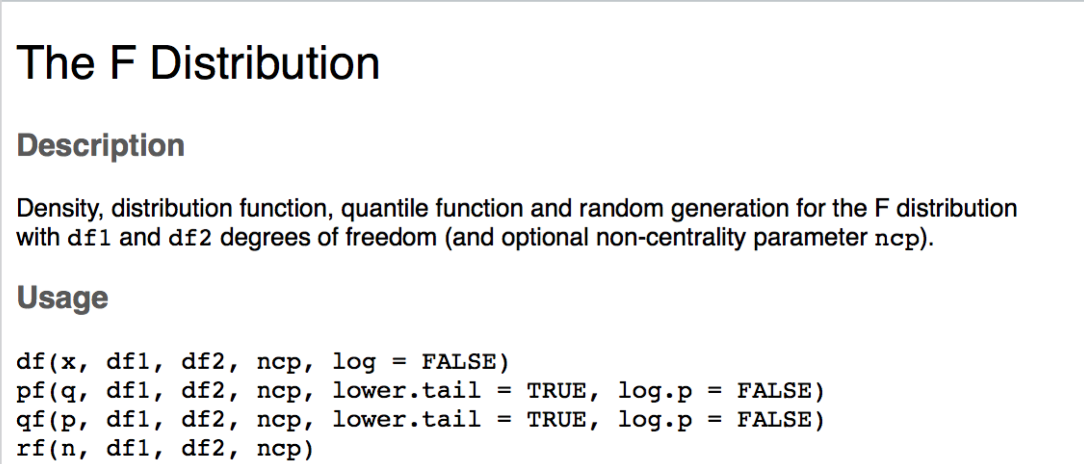

Which one should you use?

* P = probability distribution function
  + This function gives you the p-value associated with a specific F(df,df) combination.
  + q = F, df1 = df between, df2 = df within
* Q = quantile distribution function
  + This function gives you the F cut off for an associated p and (df,df) combination.
  + p = alpha/p value, df1 = df between, df2 = df within

Try:

